

**Affiliated to Gauhati University**

**Supporting Documents**

**for NAAC AQAR**

**Period: 2022-23**

|  |  |
| --- | --- |
| **Criterion 5:** | **Student Support and Progression** |
| **Key Indicator:5.1** | **Student Support** |
| **Metric Number: 5.1.3** | ***Capacity building and skills enhancement initiatives taken by the institution include the following*** |



**Affiliated to Gauhati University**

|  |  |
| --- | --- |
| |  | | --- | | **The Application Of Mathematics** | |



**Affiliated to Gauhati University**

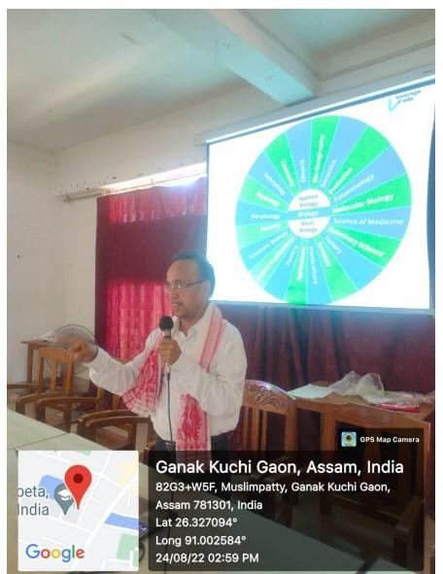

|  |
| --- |
| **Future Prospects Of Students Of Bsc** |



**Affiliated to Gauhati University**

|  |
| --- |
|  |

|  |
| --- |
|  |

|  |
| --- |
| **Periodic lecture Series-Critical (Deptt Of.Philoshophy)** |

|  |
| --- |
| **Affiliated to Gauhati University** |

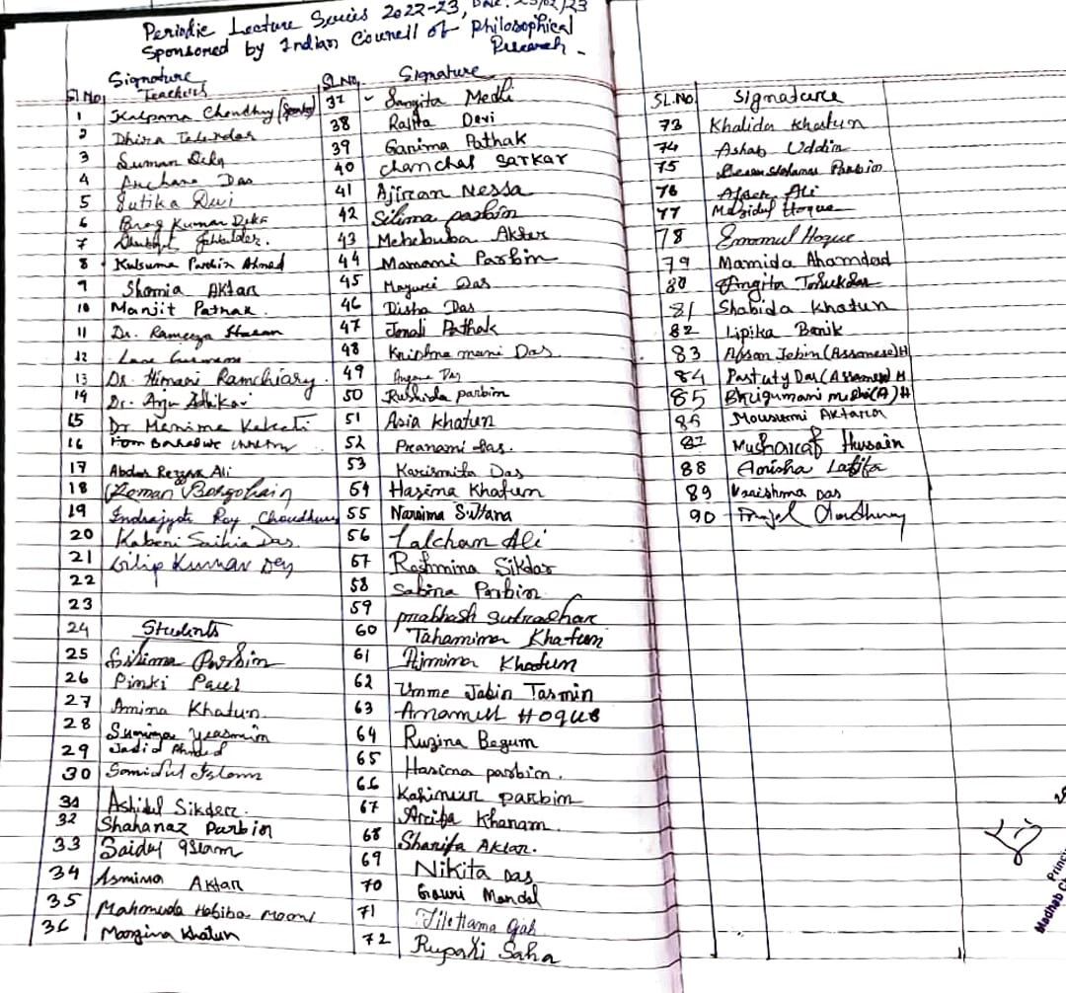

|  |
| --- |
| **Periodic Lecture Series-Exploring.(Deptt.Of Philosophy)** |



**Affiliated to Gauhati University**

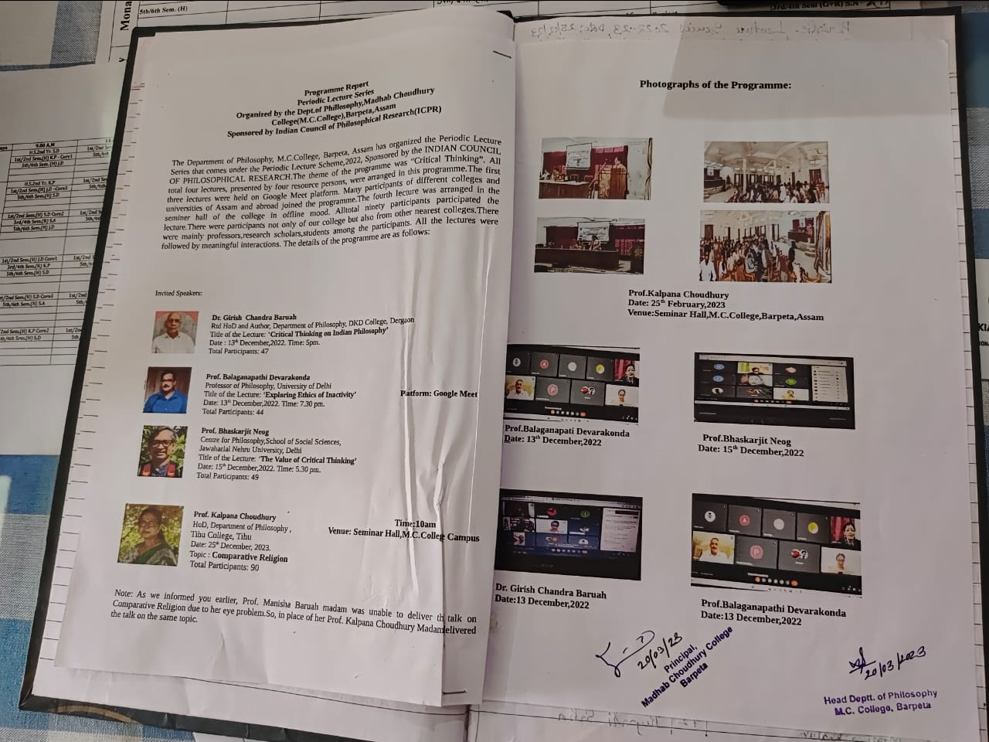

|  |
| --- |
| **Periodic Lecture Series-The Value.(Deptt.Of Philosophy)** |



**Affiliated to Gauhati University**

|  |
| --- |
|  |

|  |
| --- |
| **Periodic Lecture Series-Compare.(Deptt.Of Philosophy)** |



**Affiliated to Gauhati University**

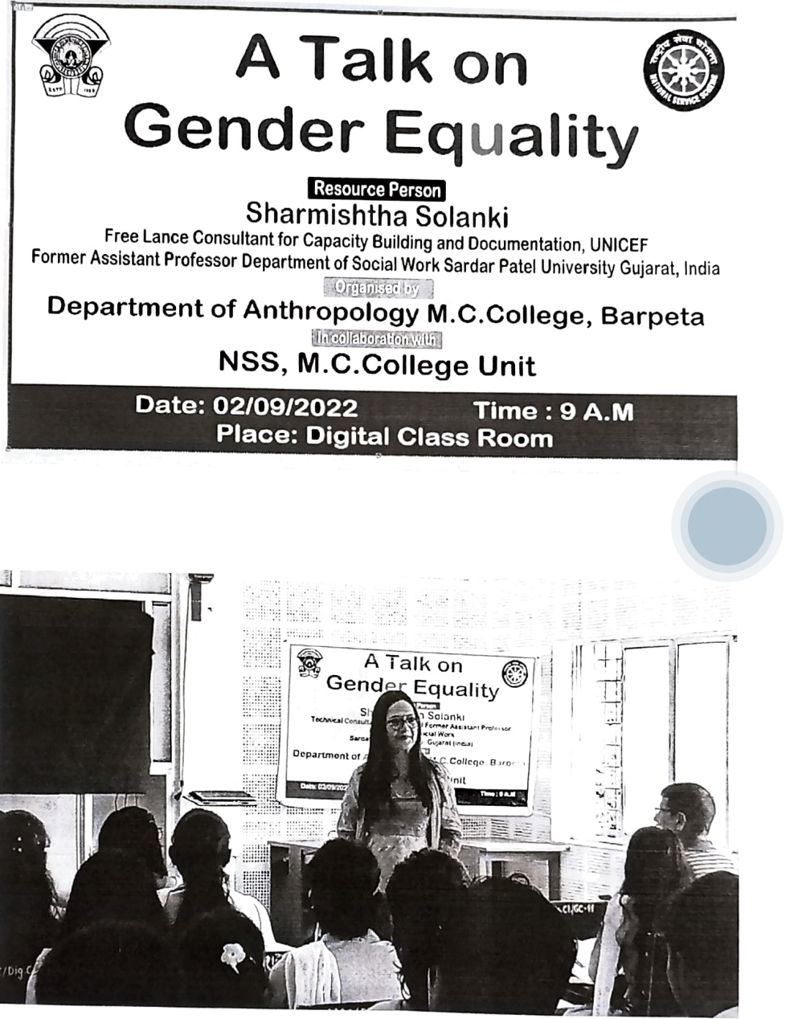

|  |
| --- |
| **A Talk On Gender Equality** |



**Affiliated to Gauhati University**

|  |
| --- |
|  |

|  |
| --- |
| **A Talk On Gender Based Violence** |

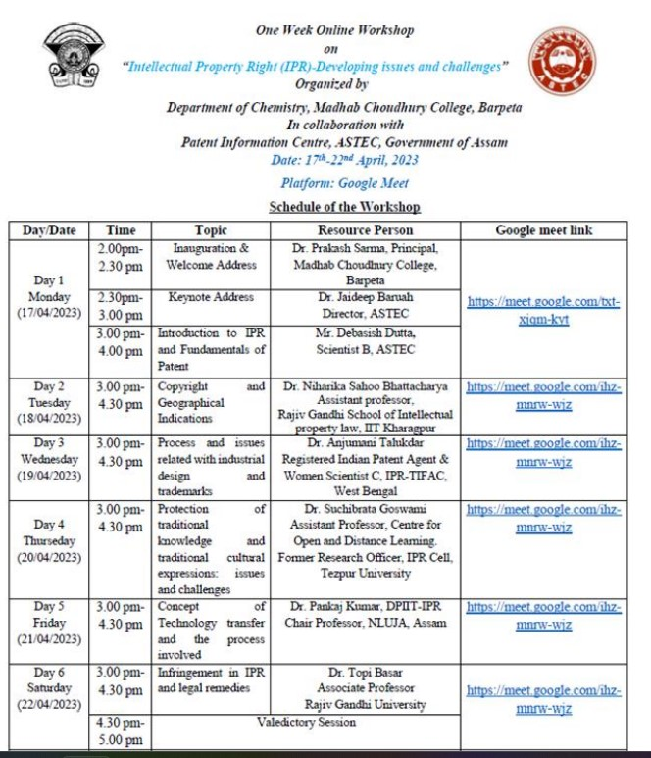



**Affiliated to Gauhati University**

|  |
| --- |
| **Workshop On IPR(Developing Issue)** |



**Affiliated to Gauhati University**

|  |
| --- |
|  |

|  |
| --- |
| **Discuss On Chemistry Nobel 2023** |

|  |
| --- |
| **Affiliated to Gauhati University** |

|  |
| --- |
|  |

|  |
| --- |
| **Special Lecture On “Exploring Div”** |



**Affiliated to Gauhati University**

|  |
| --- |
|  |

|  |
| --- |
| **Lecture Programme On Women** |



**Affiliated to Gauhati University**

|  |
| --- |
|  |

|  |
| --- |
| **Educational Tour (Deptt.Of Education)** |

|  |
| --- |
| **Affiliated to Gauhati University** |
|  |

|  |
| --- |
| **A Seminar Presentation On Indian (Deptt.Of English)** |

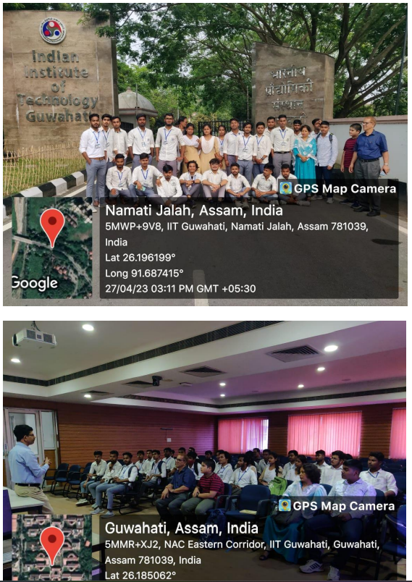



**Affiliated to Gauhati University**

|  |
| --- |
| **Educational GTour IIT ,Guwahati (Deptt. Of Physics)** |

|  |
| --- |
| **Affiliated to Gauhati University** |
|  |

|  |
| --- |
| **Educational Tour To Fish Diversity(Deptt.Of Zoology)** |